**NOTE: This is an official document by Indexademics. Unless otherwise stated, this document may not be accredited to individuals or groups other than the club IDX, nor should this document be distributed, sold, or modified for personal use in any way.**

**IDX G9 GEOGRAPHY H STUDY GUIDE ISSUE 6**

**By Ethan Swee and Heidi**

**KARST TOPOGRAPHY:**

**Formation of Karst:** - chemical erosion (permeable limestone + weak carbonic acid = soluble bicarbonate ion and calcium ion) (weak carbonic acid formed by H2O and CO2).

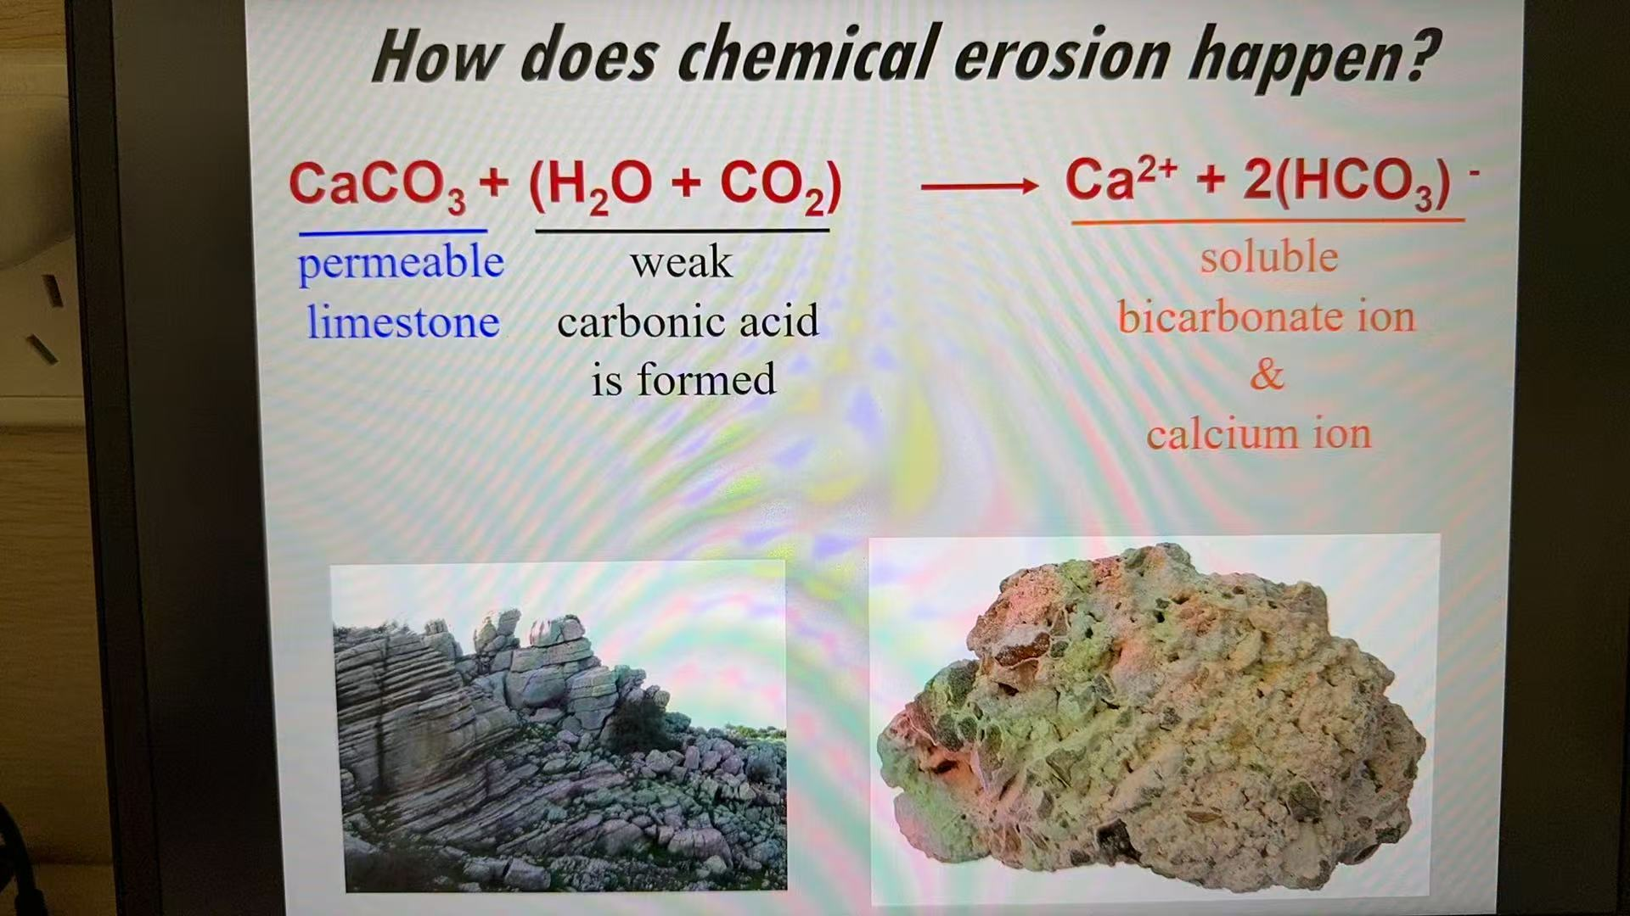

**Essential Conditions for Karst Formation:** - massive, thickly bedded, highly soluble rocks (e.g. limestone) – aerated zone (so that surface drainage may disappear through sinks to have subsurface drainage so that caves and passages may be formed) - joints in impermeable limestone - flowing groundwater - high humidity (enough rainfall) - warm climate - green covers (produce organic acid)

**Joints:** - small cracks in the Earth’s crust, no movement; formed when rocks are compressed or stretched to their breaking point; rarely pose any threat to civilization.

**Faults:** - larger cracks in the earth’s crust, have movement; formed by constant tectonic movement; can cause deadly earthquakes and tsunamis.

**Conditions in Which Karst Don’t Form:** - if carbonic rocks form above the water table, the CO2 would escape into atmosphere, so karst wouldn’t be able to form; if the soluble rock is covered by superimposed rock strata, karst may be completely absent because the water and CO2 would be unable to reach the rock.

**Headward Erosion:** - the river flows down an overhang; the upper layer of the riverbed is made of resistant strata, but the lower layer is made of less resistant strata; the water erodes the lower part of the cliff, and after a period of time the upper layer collapses, so the overhang retreats.

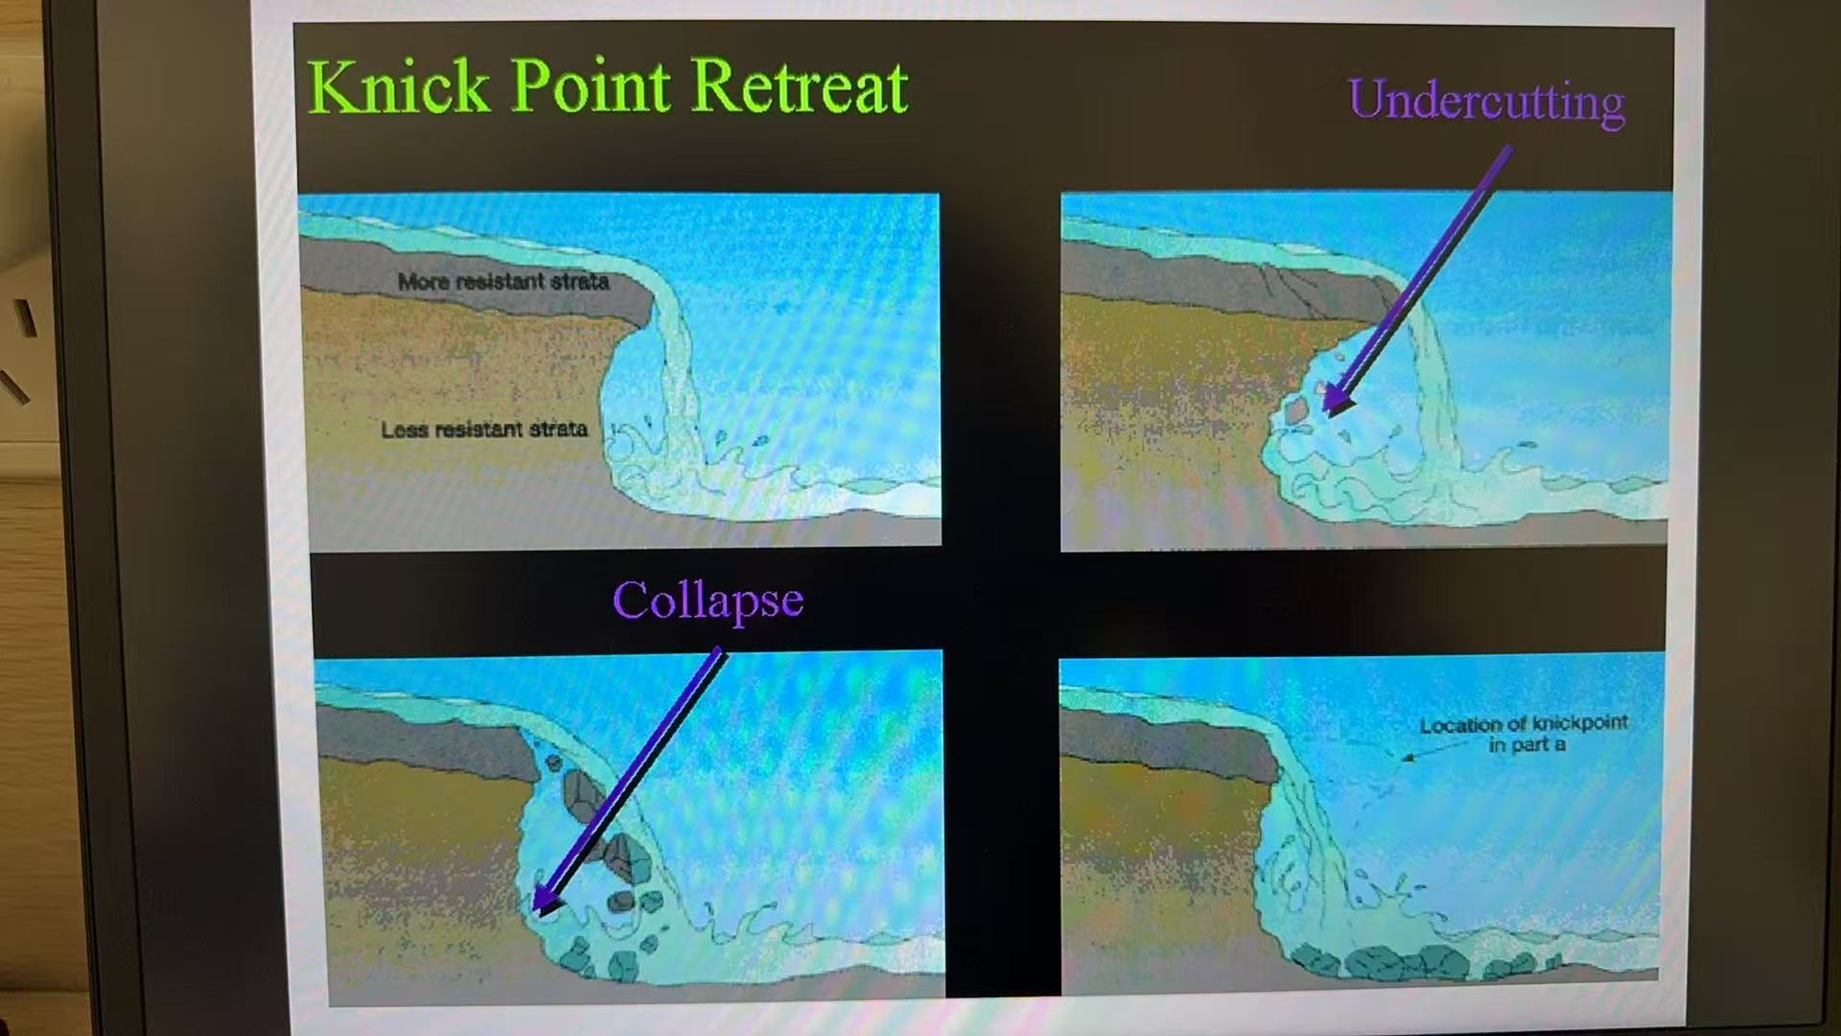

**Stream Piracy (Hijacking):** - a stream erodes its riverhead into the path of another stream and changes the flowing path of that stream.

**Lifecycle of Erosion in Karst Topography:** - early youthful stage (normal surface drainage/streams); late youthful stage (streams start to disappear into swallow holes and become underground streams); mature stage (headward erosion happens on the streams and carves out a long surface hollow); old age stage (the stream carves out valleys in the permeable rock).

**General Distributions of Karst:** - karst regions cover 15% (or 7-12%) of the Earth’s surface; 1/4 of the world’s population depend on water supplied from karst areas.

**SURFACE KARST LANDFORMS:**

1. **Limestone Pavement:** - exposed area of limestone; joints are widened by chemical weathering.
2. **Doline (Sinkhole) Karst:** - most common; rolling plains pocked with tens or hundreds of sinkholes, but there are few surface streams or surface valleys.

**Three major ways of forming sinkholes:**

1. Solution Doline: thin overburden on carbonate bedrock; the overburden (sand, etc.) fill joints in the rock, creating a funnel-shaped depression in the ground. No subsurface cave system.
2. Subsidence Doline (Shake Holes): a column of overlying sediments (mostly sand) settles into vacated spaces in the carbonate bedrock below (a process called “piping”). The slow downward erosion eventually forms small surface depressions 1 inch to several feet in depth and diameter.
3. Collapsed Doline: overlying sediments (mostly clay, harder than sand) break off in small bits and fall into joints in the bedrock, leaving a small cavity where the sediment broke off (called “spalling”). As the spalling continues, the covering sediments form a structural arch. The cavity becomes larger and migrates upward by progressive collapse. The cavity eventually breaches the surface, creating sudden and dramatic sinkholes. Compared to the other two, collapsed dolines have steeper edges due to the sudden collapse.
4. **Disappearing River and Swallow Hole:** - a river disappears into a swallow hole.
5. **Dry Valley (Uvala):** - a flat floor and steep walls. (River of resurgence: where a river reappears at the surface).
6. **Cockpit Karst:** - common in tropical regions; enclosed depressions with multiple sides, and round-topped, conical hills (桂林“峰丛”). Formation: the “solution” theory (heavy rainfall eroded the fissures and washed the debris through the sinkholes eventually out to sea); the “collapse” theory (collapse of cave systems). Typically covered by rain forest; the flat depression area suitable for human habitation and cultivation; it is the early stage of development.
7. **Tower Karst:** - more common in tropical regions; rare; formed by fast tectonic uplift and tropical karst erosion. Steep-sided forest-covered hills; many have flat tops; it is the latest stage of development.
8. **Natural Chimneys:** - a steep, chimney-like feature; too steep for vegetation to grow. Serves as a link between the surface and underground cave systems. Some are hollow, some are not.
9. **Natural Bridge:** - very, very rare. (No words on the PPT but it’s rare)

**UNDERGROUND LANDFORMS:**

**Caves and Caverns:** - develop at or below zone of saturation. Caves are smaller, have openings aboveground or on mountains, dry. Caverns are larger, have their openings underground, and may continue to be eroded by water.

**Stalactites:** - grow downward from the top of the cave. Formed by drops of water containing dissolved limestone that seep down through fissures in the cave roof. These drops of water lose carbon and deposit calcite; over time the deposition of calcite forms stalactites hanging down from the roof of the cave. May or may not be hollow inside; are thin and fragile.

**Stalagmites:** - grow upward from the floor of the cave. Formed by water droplets falling to the cave floor; these drops also lose carbon and deposit calcite. Over time these droplets form stalagmites that grow upward *directly below stalactites*. Stalagmites are thicker than stalactites.

**Pillars/Column:** - stalactites and stalagmites that grow toward each other and join to form a pillar/column.

**Curtains:** - rainwater drips from a long crack in a cave roof form a continuous strip of stalactites.

**Soda Straws:** - very thin, very small stalactites (look like soda straws!)

**Terraces/Flowstone:**

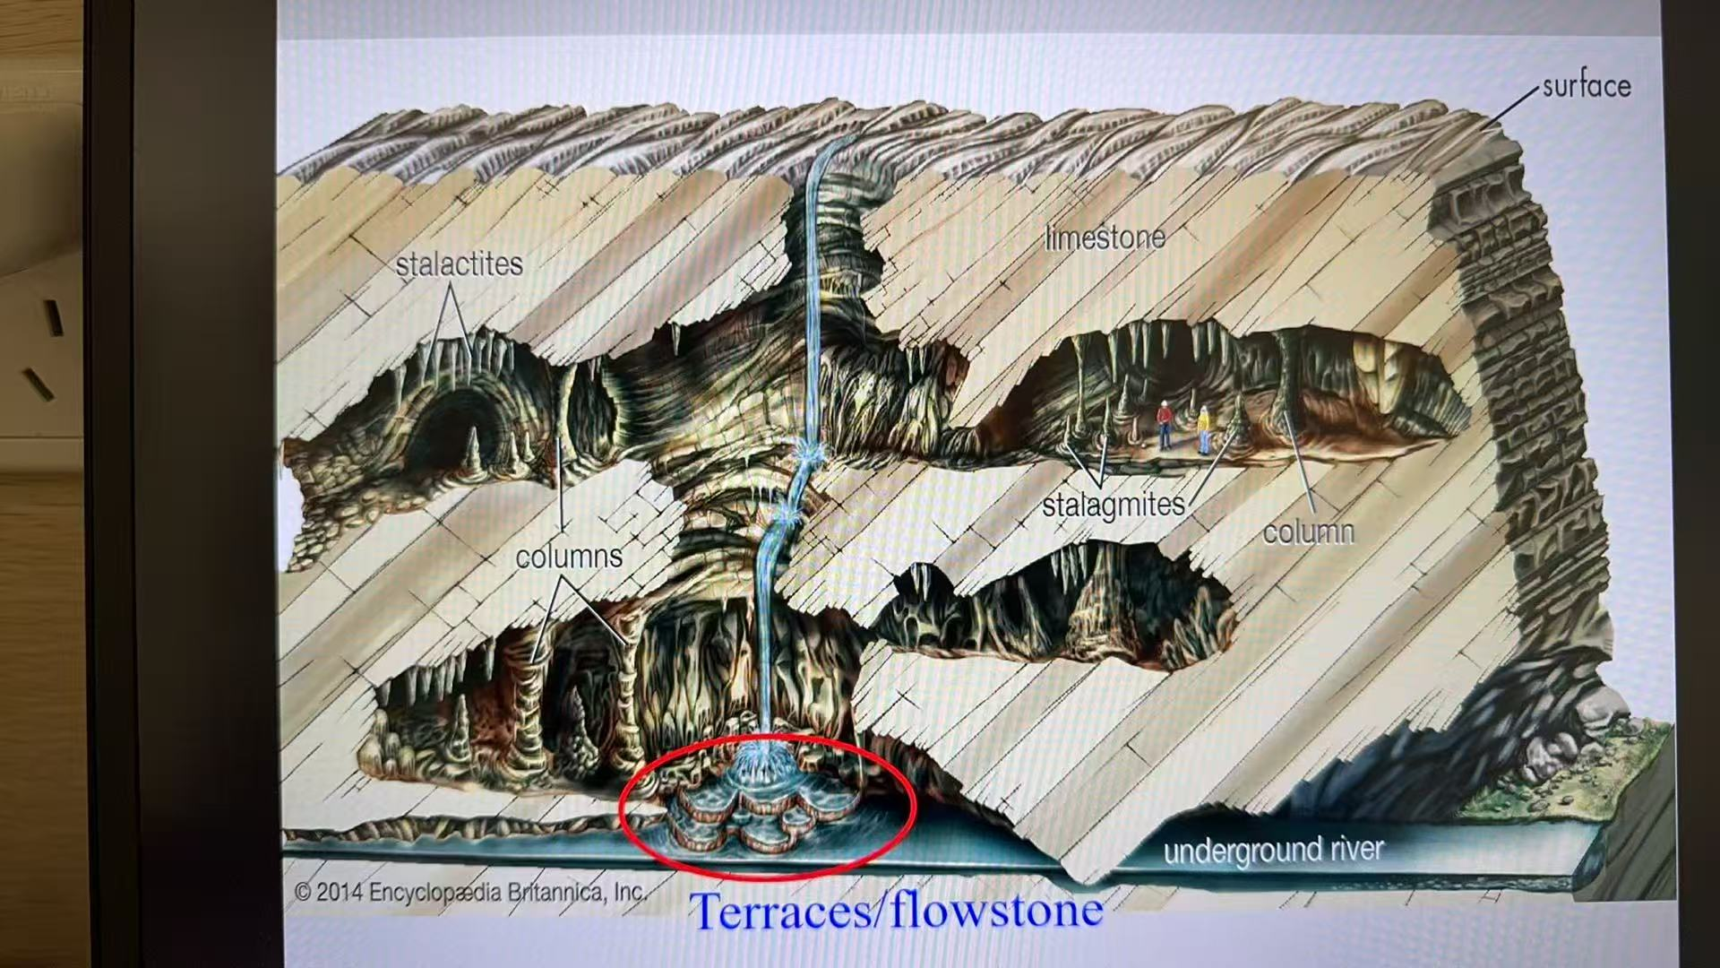

**Why Karst Matters:** - karst controls surface water (e.g. artesian well, base flow). Karst contains tremendous groundwater resources. Karst caves are special habitat. Karst caves are recreational resources (e.g. you can go explore them, which may be a sport?). Karst caves contain cultural resources (e.g. cave paintings). Karst groundwater can be easily polluted. Karst can be hazardous (sinkholes).

**Drainage patterns:**

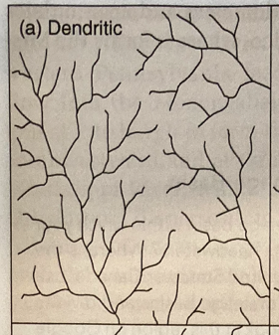

Dendritic drainage: most common drainage pattern. Treelike, very efficient energy expenditure since the total length of the branches is minimized. Forms on flat terrain and isn't influenced by faults or folds.

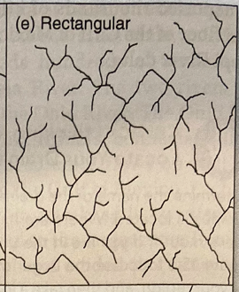

Rectangular drainage: formed by a faulted and jointed landscape — this directs the stream into 90° turns.

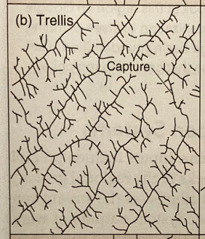

Trellis drainage: characteristic of dipping/folded topography. Seen in parallel mountain ranges, influenced by folded rock structures that very in resistance to erosion. Tributaries join main stream at right angles.

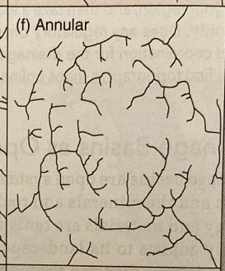

Annular drainage: occurs on structural domes, with concentric patterns of rock guiding stream courses. Erosion cuts out steps on the dome, where streams start to form.

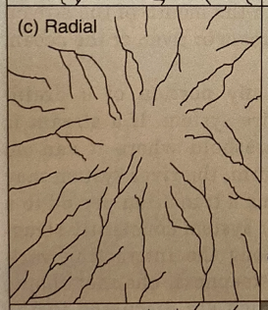

Radial drainage: results when streams flow off a central peak/dome, for example a mountain or volcano. Valleys causes by erosion as a result of this drainage pattern are called radial valleys.

Centripetal drainage: opposite of radial drainage. Occurs on basins surrounded by highlands. Usually there's a lake at the bottom, but in dry areas there might just be salt flats for most of the year.

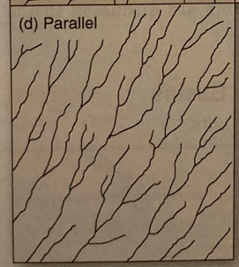

Parallel drainage: associated with steep slopes, so both the tributary streams and main streams flow directly downwards.

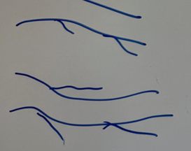

Angular drainage: also formed in jointed landscapes. Water erodes preexisting joints. Where fractures meet, sharp joints form. Secondary fractures can also develop over time.

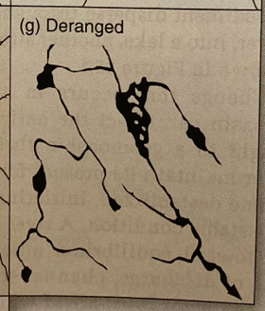

Deranged drainage: no clear geometry and no true stream valley. Appears often in glacial regions.

**Basic fluvial concepts:**

**Gradient:** the drop in elevation per unit distance.

—Formula: rise/run. No unit.

**Base level:** the level below which a stream cannot erode its valley

**Ultimate base level:** sea level — average level between high and low tides

—exceptions include when streams empty into closed depressions.

**Local base level:** river or lake determining the lower limit of local or regional stream erosion (temporary)

—can be some very hard rock/lake/reservoir

**Discharge:** a stream's volume of flow per unit of time.

—Formula: cross sectional area (m^3) x average velocity of river (m/s). Unit is m^3/s